Ejection Fraction Analysis for Male and Female

Males

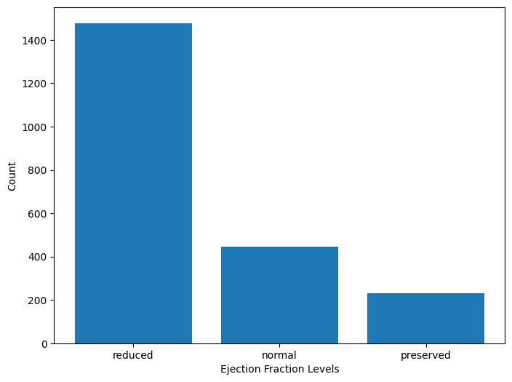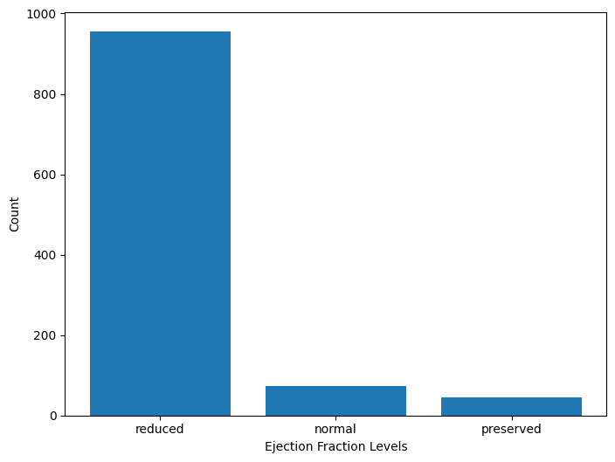

According to the graphs, it appears that preserved and normal levels are more prevalent in the Male survivor population in contrast to the mortality population. We can infer that the preserved and normal levels of ejection fractions play a role in mortality for males. Therefore it’s less likely that a datapoint in the mortality population will exhibit normal and or preserved ejection fraction levels.

Females

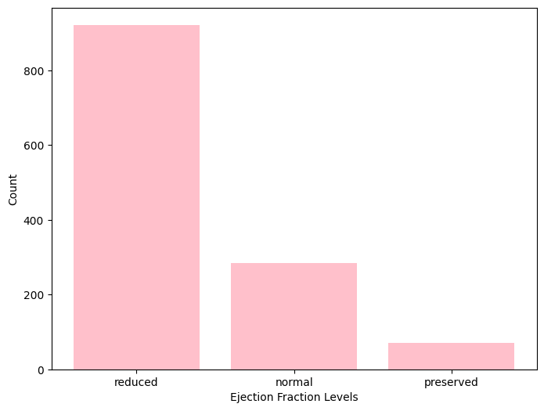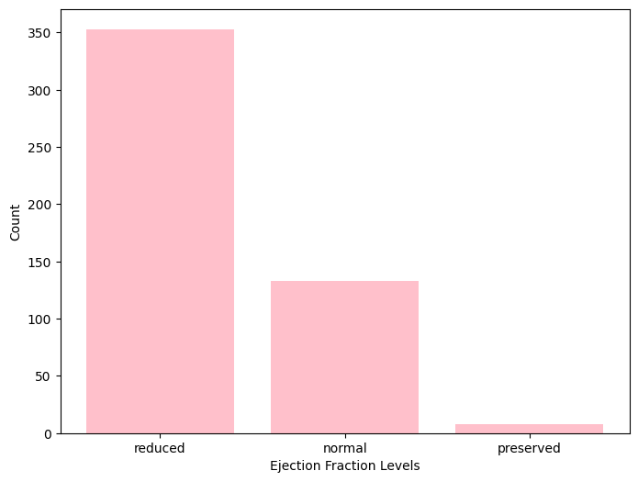

According to the graphs, it appears that in the survivor population, preserved levels appear to be more prevalent, then in the mortality population. This suggests that a datapoint the mortality population is less likely to have preserved ejection fraction levels in the female population therefore females with a preserved EF level will more likely to survive and that low EF levels are associated with high mortality.

* keep both male and female scale the same 0 to max number of male/female participant
* ex. 10 % of the survival female pop has red ef and 2% had nor ef and 1% had preserved ef
* ex. total number of male participants were 6000 and 3000 survived and 3000 died. from the survival population of 3000 2000 had reduced EF, 500 have normal ef and 500 had preserved EF. therefore out of the male survival population of 3000, 50% had reduced ef, 25% had normal and 25% had preserved.

Key Points:

Survivors:

Both male and female with preserved to normal EF levels are more likely to be in the survival populations. This indicates a protective role for higher EF levels for both genders.

Mortality:

Both males and females in the mortality population are less likely to have preserved and normal EF levels. This suggests that reduced EF levels are a risk factor for higher mortality for both genders.

Gender Specific Observations:

While preserved and normal EF levels are critical for survival in both male and female populations. Preserved EF levels appear to be a strong indicator for survival among the females.

Therefore, the implication is that monitoring and maintaining EF levels might be important for survival among females.

The analysis highlights that preserved and normal ejection fraction levels are associated with higher survival rates in both males and females. However, preserved levels have a more pronounced effect on the female population's survival. This indicates the importance of maintaining healthy EF levels to improve survival rates and suggests that targeted strategies might be necessary to address gender-specific differences in heart health outcomes.